**Urban vs. Rural and Principal Component**

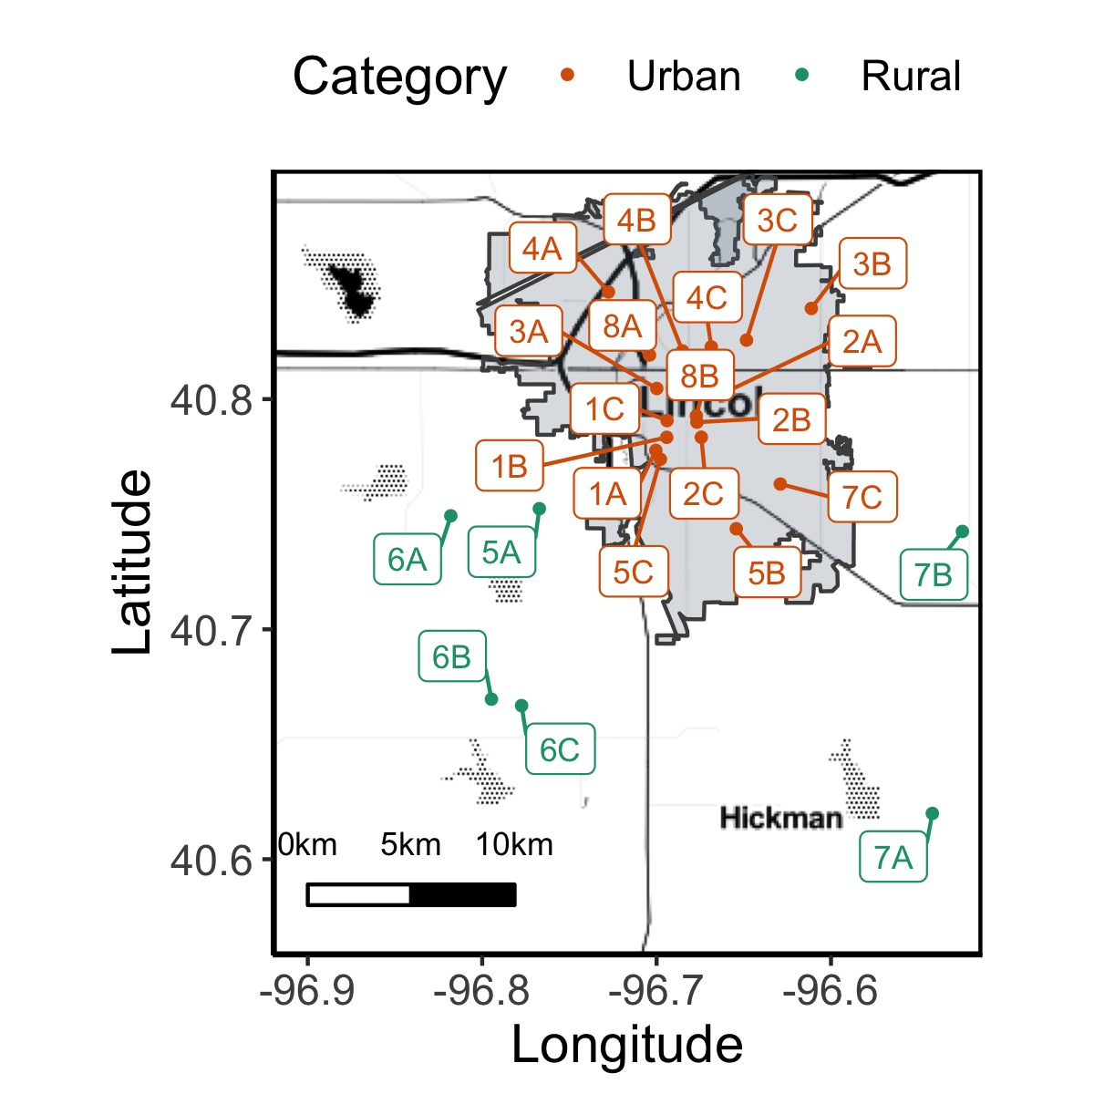 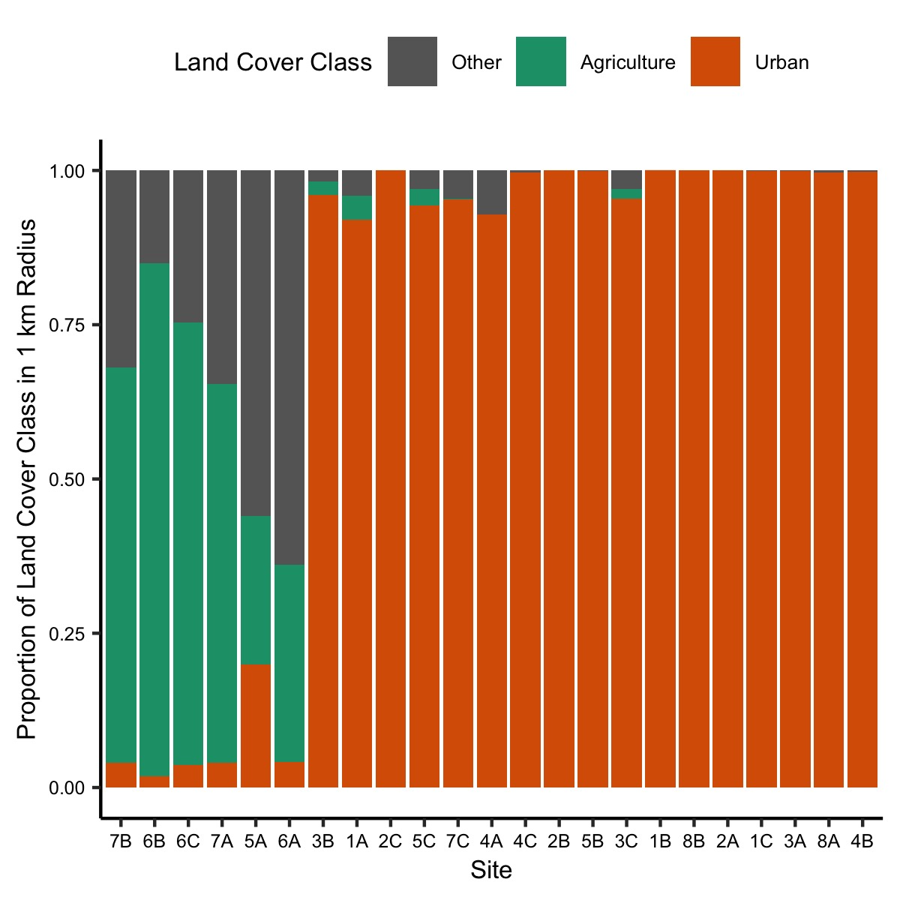 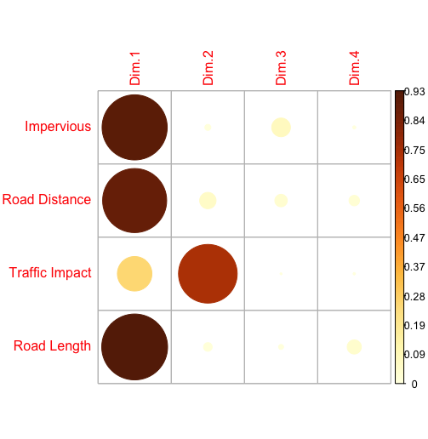 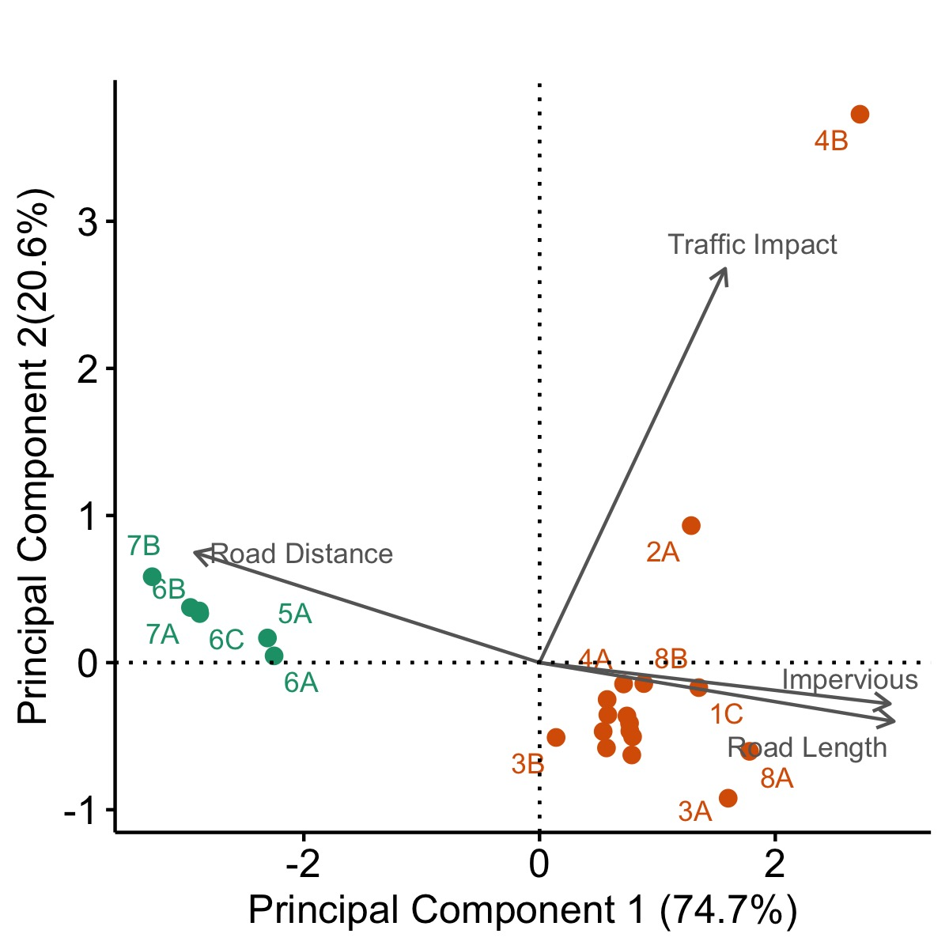

Used land cover class proportions to assign urban and rural. Urban sites had more urban than agricultural cover, while rural sites had more agriculture than urban. The “other” class was often classified as grassland herbaceous. The rural sites also fell outside of city limits. For spatial analysis below, we use principal component 1 as an estimate of road vibratory noise.

**Spatial Variation in Vibratory Noise**

|  |  |  |
| --- | --- | --- |
|  | t-value | P-value |
| PC 1 | 10.257 | **< 0.001** |
| Substrate | -3.298 | **0.001** |
| PC 1 x Substrate | -0.064 | 0.949 |

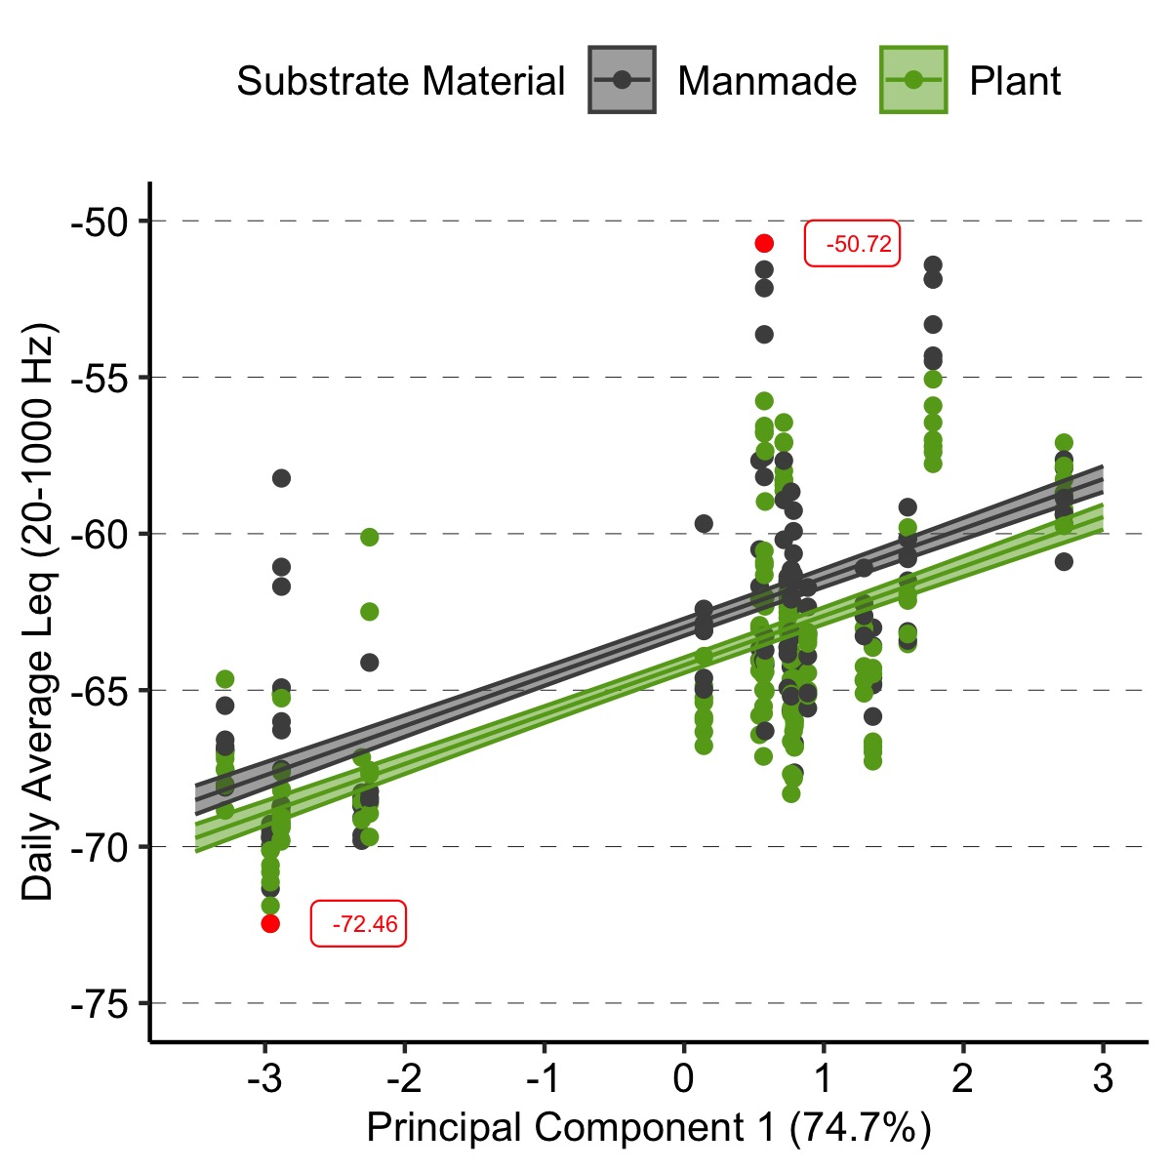

Adj. R2 = 0.45

Linear model with principal component 1, substrate, and interaction. Same results with a mixed model with site as a random factor.

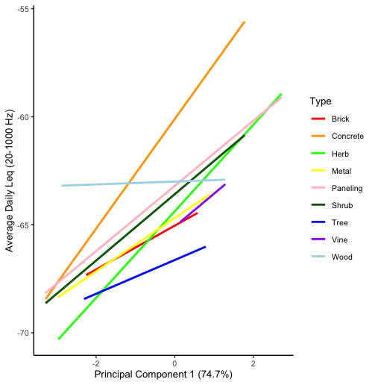

Visualization of the breakdown of substrate materials

**Temporal Variation in Vibratory Noise – Season**

|  |  |  |
| --- | --- | --- |
|  | Chisq | P-value |
| Visit | 7.3624 | **0.061** |
| Category | 20.4937 | **< 0.001** |
| Visit x Category | 3.4929 | 0.322 |

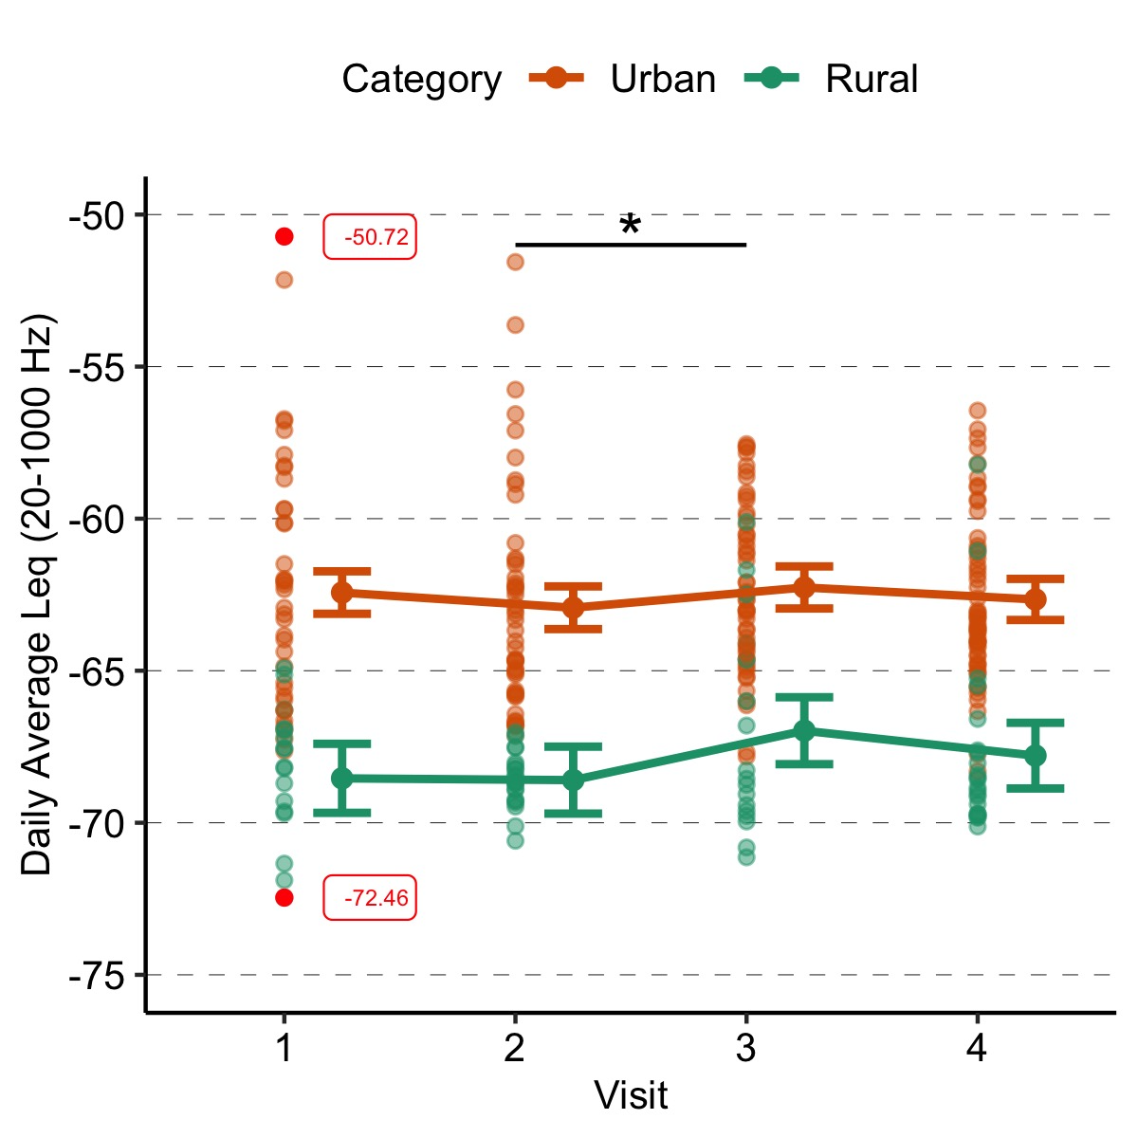

Cond. R2 = 0.753

Only 2020. Linear mixed effects model (Type II Wald chisquare tests) with visit, category, and interaction with site as a random factor. Different results without site, so we used the mixed model. Tukey pairwise comparisons of visits suggest a difference between the second and third visits (t = -3.002 P = 0.016).

|  |  |  |
| --- | --- | --- |
|  | t-value | P-value |
| Day | 1.186 | 0.237 |
| Category | -13.397 | **< 0.001** |

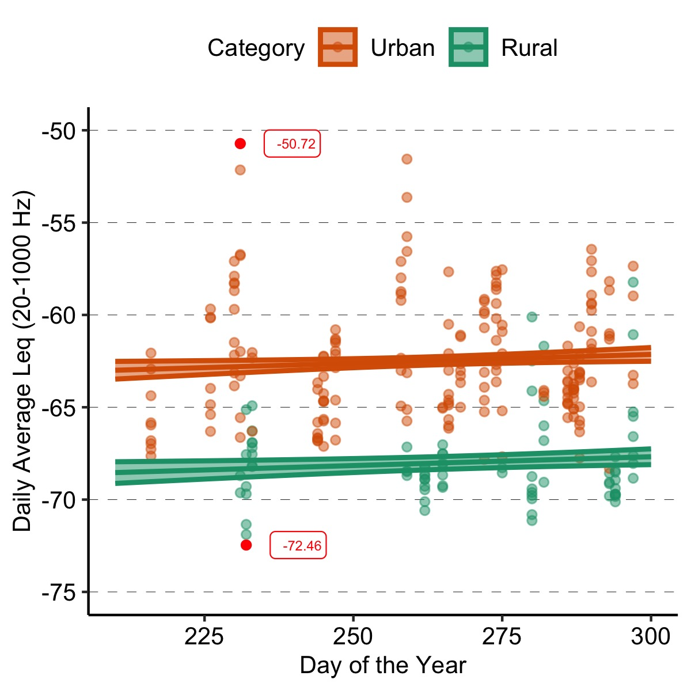

Adj. R2 = 0.3995

Only 2020. Linear model (mixed model gives similar results) with day and category. Excluded the interaction since no interaction above.

**Temporal Variation in Vibratory Noise – Harvest**

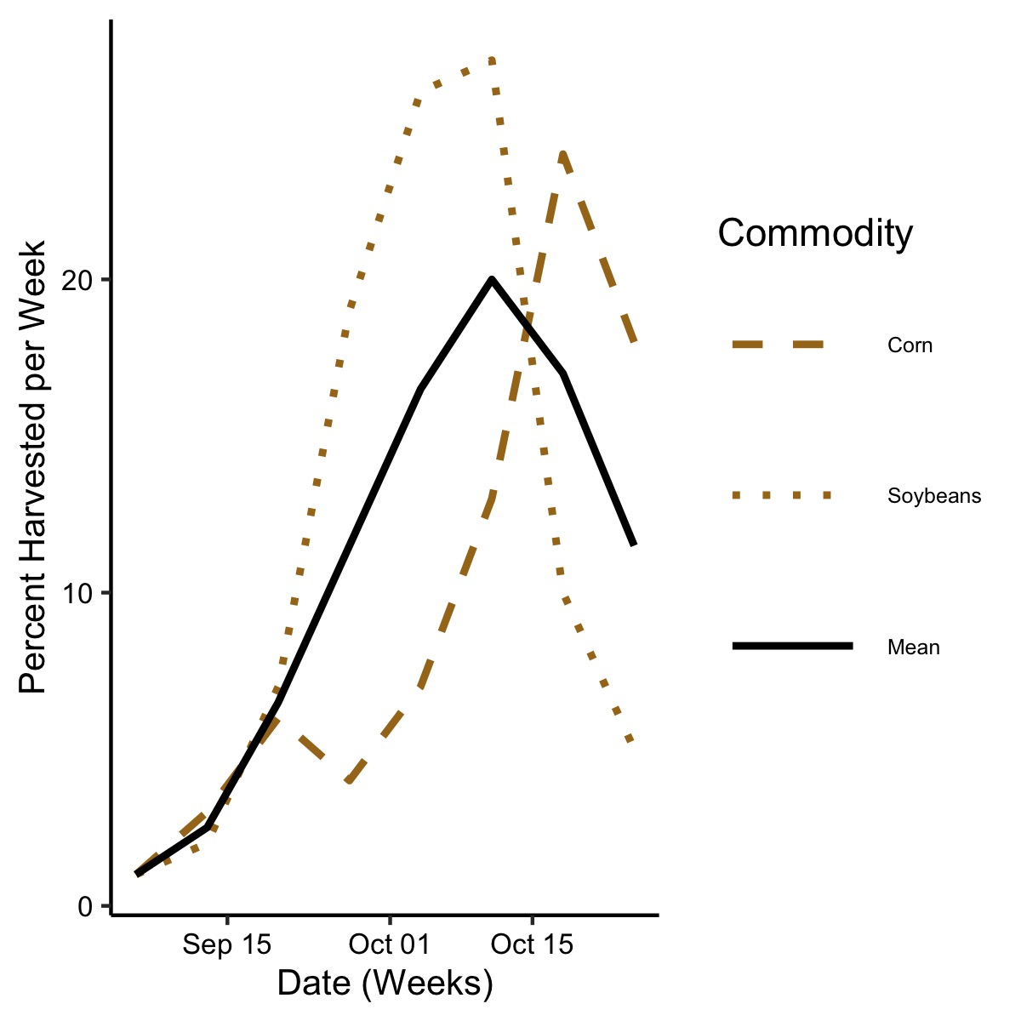

|  |  |  |
| --- | --- | --- |
|  | Chisq | P-value |
| Percent Harvested | 4.4975 | **0.034** |

USDA data on corn and soybeans harvest in Nebraska during study season in 2020. Excluded oats, wheat, sorghum, and dry beans.

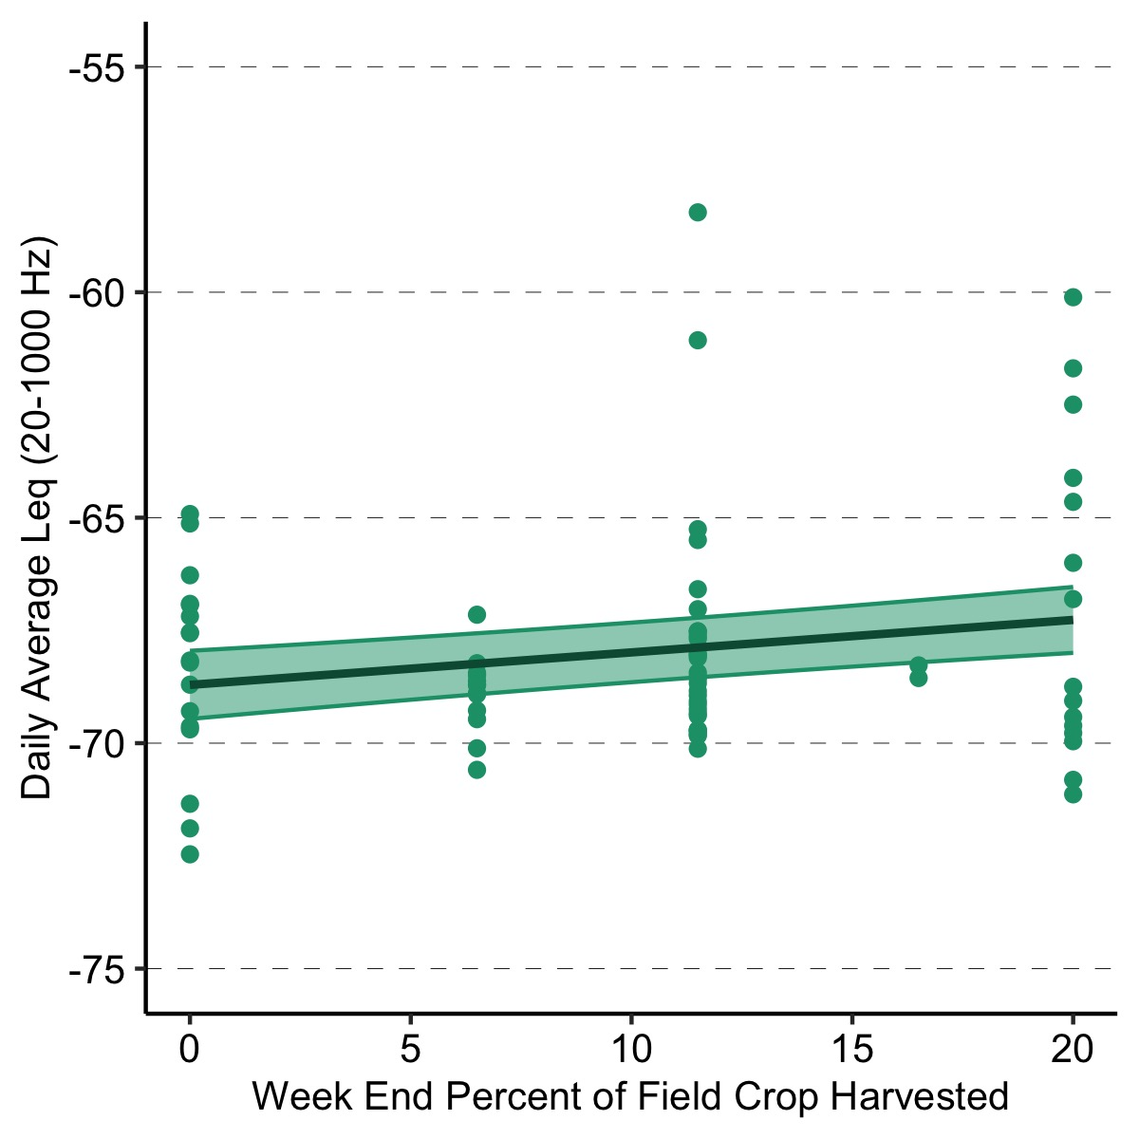

Cond. R2 = 0.381

Only rural in 2020. Linear mixed effects model (Type II Wald chisquare tests) of percent harvest with site as a random factor.

**Temporal Variation in Vibratory Noise – Hourly**

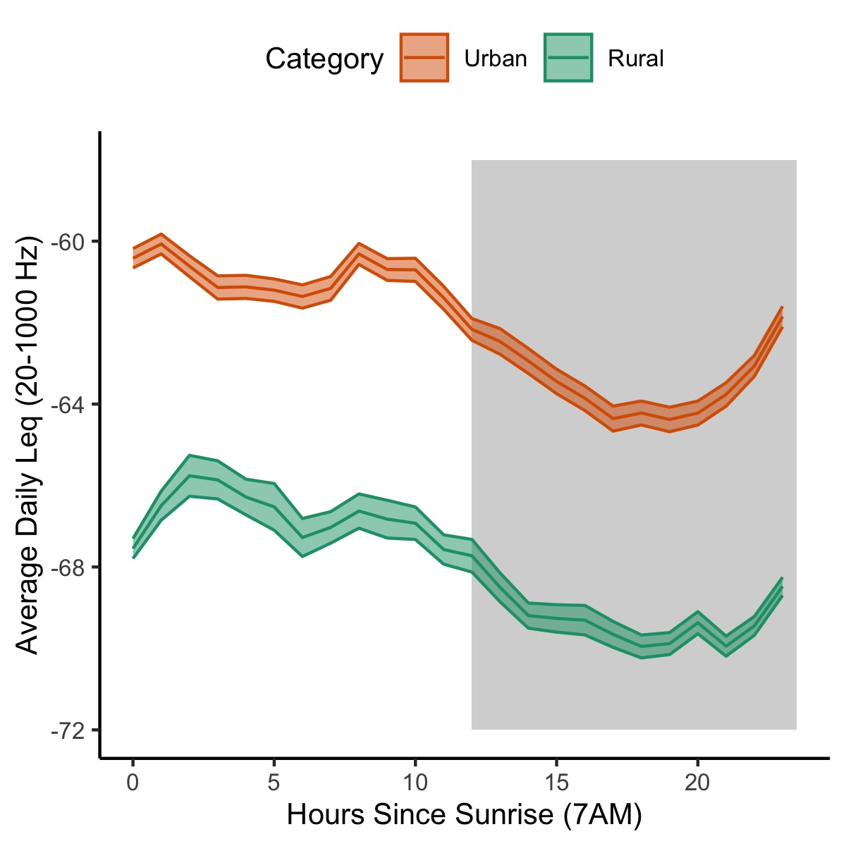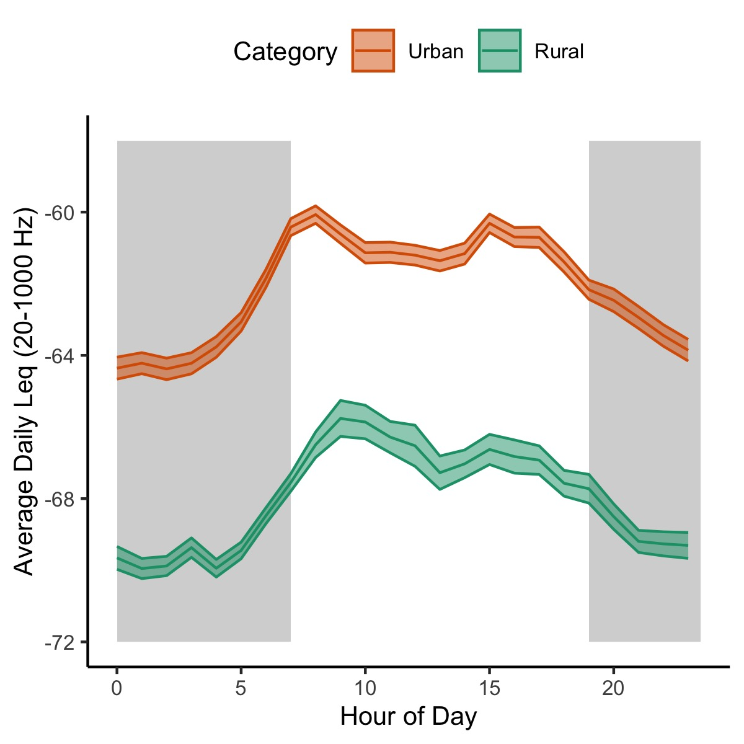

Raw data for trends in 24 hours

|  |  |  |
| --- | --- | --- |
|  | Chisq | P-value |
| Hour | 1179.077 | **< 0.001** |
| Category | 18.2298 | **< 0.001** |
| Hour x Category | 0.1551 | 0.694 |

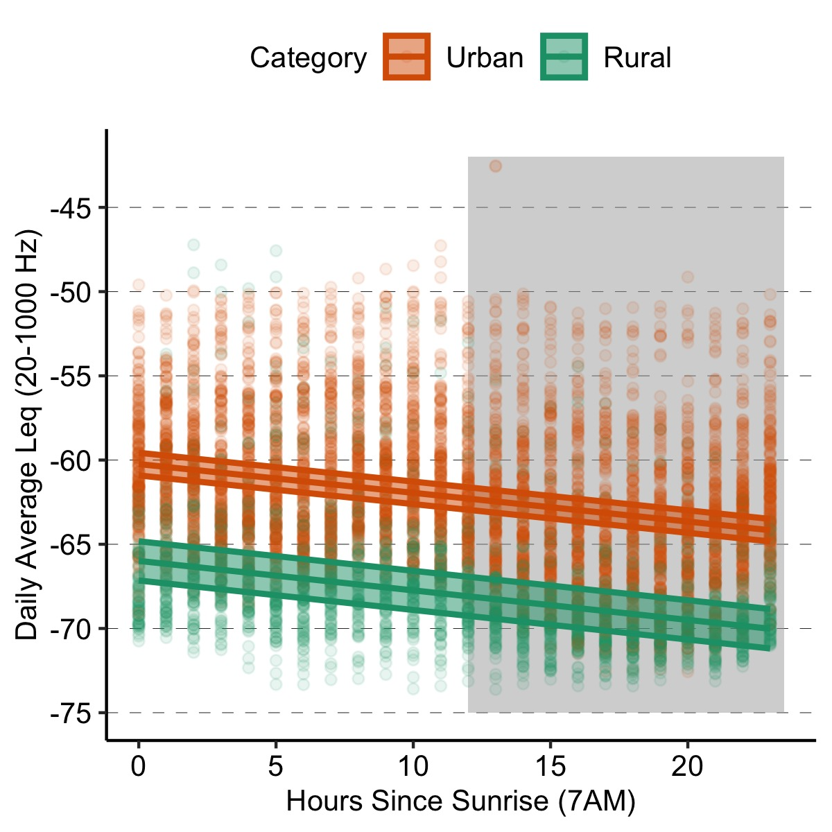

Linear mixed effect model (Type II Wald chisquare tests) of hour, category, and interaction with site as a random factor.

**Summary Visualizations**

